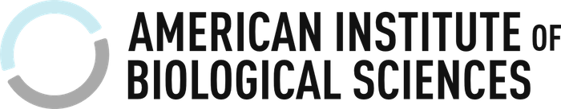

American Institute of Biological Sciences & Contest Sponsors Photo Release

The following conditions are understood, and agreed to, for any and all submissions to the American Institute of Biological Sciences and their photo contest sponsors (“All Sponsors”, as identified in the photo contest rules) :

- If I am the photographer of the image associated with this release…
  - I grant All Sponsors, a perpetual, irrevocable, and royalty free right to use or publish, in any manner, the photograph, in whole or in part and in any medium, without any form of further permission required or granted, and to include my name and any other information submitted, in photo captions or other texts.
  - I hereby waive my right to inspect or approve any copy or derivation that is used in any way in connection with the photograph or information submitted.

- If I am present and recognizable in the image associated with this release…
  - I grant perpetual, irrevocable, and royalty free permission to All Sponsors to use my photographic likeness, and/or any other information provided by the photo submitter, including but not limited to my name, in photo captions or other texts.

Print Name:

Signature:

Date:

